SPECIALISTS IN ALL KINDS OF PIPELINES, ROTARY EQUIPMENTS, FABRICATION,
ERECTION, AND PLANT MAINTENANCE.

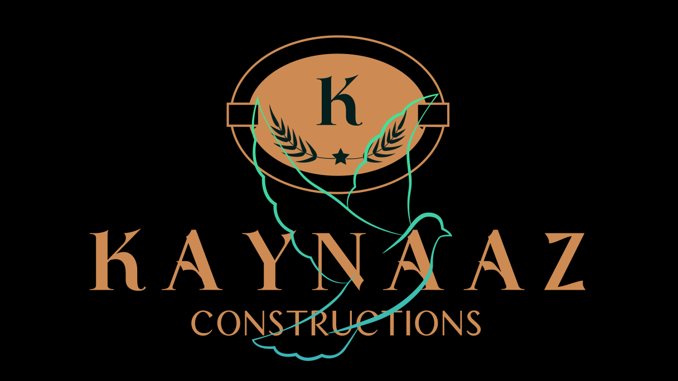

Profile

COMPANY PROFILE

Date: 05-06-2024

Dear Sir,
Let us introduce our self as one of the leading contractors handling mechanical jobs in
our industrial sector since the last 7 years. Our field of operations includes Erection, Alignment and Commissioning of Rotary Equipment’s including refurbishing, Fabrication, Erection and Piping, Production Maintenance and Shutdown jobs related with Steel plants, Power Plants etc.

We are herewith enclosing the details of our establishment for your ready reference.
- Introduction Annexure 1
- Organization, Registration with statutory authorities and organizational set up Annexure 2
- Persons to Contact Annexure 3
- Details of Major Works Executed Annexure 4
- List of Machineries and Tools Annexure 5

We are confident to carry out and complete any types of jobs related, keeping maximum quality and safety within the scheduled time. Hence we are awaiting for your valuable enquiry.

Thanking you, Yours Truly,

For Kaynaaz Constructions

MD MERAJ ALAM
Founder

KAYNAAZ CONSTRUCTIONS

INTRODUCTION
Established in 2019, KAYNAAZ CONSTRUCTIONS is engaged in Erection, Alignment, Testing and Commissioning Rotary Equipment’s together with Structural Fabrication and Erection and All Kinds of Piping including Hydraulics and Lubrication etc., connected with different industrial projects in Karnataka and also in maintenance of running plants, production and shut down jobs.

Internal Cells for Co-ordination, Quality Control and Safety are assisting and guiding in our day to day smooth functioning.

With the successful handling of several projects and a countable service in field of Construction KAYNAAZ is having a well experienced team of Administrators, Engineers, Foremen, Technicians and Skilled Workmen able to handle any type of Projects at any circumstances. Having sufficient tools in hand and can arrange any tools and tackles on demand the mobilization consumes minimum time as far as we are concerned.

With such an infrastructure we can ensure the execution of any type of project, having any range, maintaining maximum quality and Completion within the scheduled time.

Details regarding Organization set up, Registration with statutory authorities, executed jobs, man power, Tools and tackles are enclosed here with for reference.

For Kaynaaz Constructions

MD MERAJ ALAM
Founder

KAYNAAZ CONSTRUCTIONS

ORGANISATION

Name of the Firm : KAYNAAZ CONSTRUCTIONS.

Mail Address : Shankar Gowda colony Toranagallu, Post, Karnataka State - 583123
Telephone Numbers : 7795828031

E-mail : ma9944913@gmail.com
Nature of Works : Structural Fabrication and Erection.
All kinds of piping works.
Assembling, Erection and Alignment of Equipment’s.
Running Plant Maintenance Works. Major Shut down Jobs.
Our Bankers : State Bank of India Axis Bank

For Kaynaaz Constructions

MD MERAJ ALAM
Founder
Annex-3
PERSONS TO CONTACT

Name & Address of the Personal | Designation | Contact Telephone Numbers | E-mail Address
MD MERAJ ALAM.  Shankar Gowda Colony, Toranagallu Post, Bellary District, Karnataka – 583123 | Founder | 7795828031 | ma9944913@ gmail.com

For Kaynaaz Constructions

MD MERAJ ALAM
Founder
Annexure.5

LIST OF OUR MACHINERIES AND TOOLS

S/No. | Machinery & Equipments | Quantity
01. | Telescopic Crane GROVE-160 Ton | 1 No
02. | Telescopic Crane 50 - Ton P&H | 1 No
03. | F-15 Hydra | 4 No
04. | Hydra(Escort & ACE) | 4 Nos.
05. | Tractor with Trailer | 2 Nos.
06. | Plate Bending Machine | 2 Nos.
07. | Welding Generator | 4 Nos.
08. | Welding Rectifier | 50 Nos
09. | Welding Transformer | 20 Nos
10. | Grinding Machine AG-7 | 20 Nos.
11. | Grinding Machine GQ-4 | 8 Nos.
12. | Grinding Machine Portable | 4 nos.
13. | Drilling Machine (Magnet) | 03 Nos.
14. | Hand Drilling Machine | 02 Nos.
15. | Dumpy Level | 1 Nos.
16. | Micrometer(Inside) | 10 nos.
17. | Micrometer(Outside) | 9 Nos.
18. | Vernier Caliper | 4 Nos.
19. | Chain Pulley Blocks | 25 Nos.
20. | Master Level(0.002) | 1 Nos.
21. | Pug cutting Machine | 10 Nos.
22. | Hydraulic Pipe Bending Machine | 2 nos.
23. | Mechanical Jacks | 6 Nos.
24. | Hand Winch | 01 Nos.
25. | Motor Winch | 1 No.
26. | Theo do Light | 1 Nos.
27. | Manual Pipe Bender(Up to 2") | 5 Sets
28. | Argon Sets | 05 Sets
29. | Vibrator with needles | 4 Nos.
30. | Circular saw Cutting Machine | 2 Nos.
31. | General Tools and Safety measures such as Safety Belts,  Helmets, Gloves etc. | Sufficient`

DETAILS OF MAJOR WORKS DONE IN HSM – 2 JSW STEEL LTD BELLARY
- Erection of Utility, Gas & Tunnel piping for HSM#2 for 10 MTA CCP,
It include Oxygen, Nitrogen, Corex gas, Coke oven gas, Compressed air, fire fighting line, drinking line and air mist line.
- Fabrication and Erection of Gas Duct Line in HSM-2, up to 4mtr dia.
- Fabrication of Equipments.
- Fabrication and Erection of HMDS De-Dusting system in HSM#2, Includes Assembly and erection of Bag-filters, Structures, Chimney, and ducting.

DETAILS OF MAJOR WORKS DONE IN 5 MT RMHS JSW STEEL LTD BELLARY
- Fabrication,Erection,Testing and commissioning of Dry Fog System Piping in RMHS
- Fabrication and Erection of Yard Sprinkler piping in RMHS.
- Fabrication, erection and Alignment of De-dusting Systems in RMHS 5 Mt, Including bag filter, chimney, and ducting.
- Fabrication and Erection of conveyor Galleries.

DETAILS OF MAJOR WORKS DONE IN 5 WT RMHS JSW STEEL LTD BELLARY

- Utility and Gas Piping Fabrication and erection works in RMHS -5WT

DETAILS OF MAJOR WORKS DONE IN SMS – 1 JSW STEEL LTD BELLARY

- Fabrication, Erection and Alignment
And Commissioning of Rail track laying 1500 MT
- Fabrication, Erection and Alignment and Commissioning of Equipments, Chimney, Technological Structures, Dedusting works. 3000 MT

RECENTLY COMPLETED PROJECTS
  - Caster #4 -WCS, Utility, Hydraulic and Lubrication Piping and WCS equipment Erection and Alignment SMS-1 at JSW Steel Ltd
  - Capacity Enhancement of Conveyors of RMHS-5WT at JSW Steel Ltd.
  - Fabrication, erection and Commissioning of Dedusting System at BF-5.
  - Fabrication, erection and Commissioning of Dedusting System at COKE OVEN 5.
  - Fabrication and Erection of RH-2 piping (Water, air, Gas, Hydraulic, Lubrication, SS and Tunnel Piping) in SMS-1 at JSW Steel Ltd.
  - Fabrication and Erection of Dedusting of KR process of quantity 1400 MT.
  - Dismantling, Loading, Shifting of Tank from Halkarni and Unloading Re Fabrication & Erection of Tanks & Structures at JSW Site of Quantity 1500 MT.

For Kaynaaz Constructions

MD MERAJ ALAM
Founder

